Leap year

***Section Exam – Leap Year***

**Description**

You can determine if a year is a leap year by testing if it is divisible by 4.  But years that are also divisible by 100 are not leap years, unless they are also divisible by 400, in which case they are leap years.  To state it another way:

* Any odd year is NOT a leap year.
* Even years not divisible by 4 are NOT leap years.
* Years divisible by 4      are leap years, except for those divisible by 100.
* All years divisible by      4 and 100 and 400 ARE leap years.

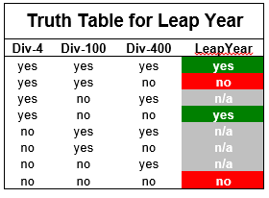

The year 2000 was a leap year because it is divisible by 4, divisible by 100 and divisible by 400.  The year 1900 was NOT a leap year because it is divisible by 4, divisible by 100, but it is NOT divisible by 400.

Write a program that allows a user to enter a year and then determines whether the year entered is a leap year.  Print a message to the user, repeating the year that was entered, as well as whether the value was divisible by 4, divisible by 100, and divisible by 400, and finally if the year was a leap year.

So, for example, if the user inputs:

***Please enter a year value:***

***1234***

then the program will output something like:

***Year entered: 1234***

***Divisible by 4: No***

***Divisible by 100: No***

***Divisible by 400: No***

***Leap year: No***

If it makes the implementation easier for you, it is also perfectly acceptable if the program output looks like this:

***The year 1234 is not divisible by 4, is not divisible by 100, is not divisible by 400, and is not a leap year.***

**Hints and Caveats:**

Remember the modulus operator tells you by a remainder of zero if one number divides evenly into another.